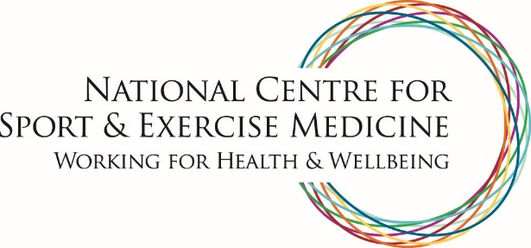

East Midlands
The focus of the NCSEM East Midlands (NCSEM-EM) is on the translation of research into frontline clinical practice and new models of patient care.
The hub of the NCSEM-EM, based at Loughborough University, co-locates academics and clinicians within one building specifically designed to facilitate interaction and collaboration.
This innovative approach breaks down barriers between academia and clinical practice, providing the opportunity to transform the way in which exercise interventions can be delivered, and expertise disseminated, resulting in both health and economic benefits.
The NCSEM-EM is a partnership between the University of Leicester, Loughborough University, The University of Nottingham, University Hospitals of Leicester NHS Trust and Nottingham University Hospitals NHS Trust.
W: www.ncsem-em.org.uk
T: @ncsemem

