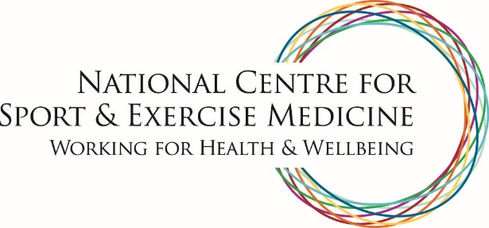

London
The London hub of the NCSEM is the Institute of Sport Exercise and Health (ISEH). The ISEH provides excellence in elite sports performance and sports injury prevention and management whilst bridging the gap between elite sport, amateur sports and exercise prescription, for the improvement of the healthcare of the population.
The ISEH is a partnership between the British Olympic Association, the English Institute of Sport, HCA International, University College London (UCL) and University College London Hospitals NHS Foundation Trust.
W: www.iseh.co.uk
T: @TheISEH

