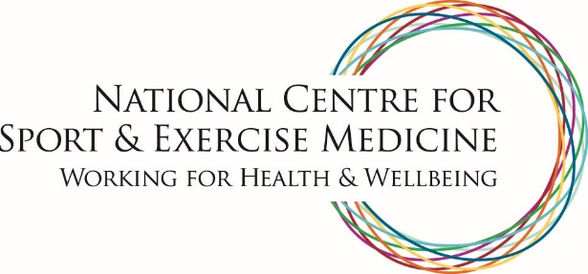

National Centre for Sport and Exercise Medicine
The National Centre for Sport and Exercise Medicine (NCSEM) is an Olympic legacy project delivering education, research and clinical services in sport, exercise and physical activity. It applies world-class expertise to policies and practice that will benefit the health and wellbeing of the nation – from everyday people at risk of ill health through to elite athletes.

The NCSEM is comprised of three regional hubs based in the East Midlands, London and Sheffield. In each hub, leading academics and healthcare professionals are brought together to build on existing research in the field of sport and exercise medicine and facilitate the effective and efficient transfer of research into frontline practice.

The research, education and clinical activity of the NCSEM covers five key themes:
- Optimising health and wellbeing, through lifestyle, physical activity and nutrition
- Exercise in the management of health conditions
- Rehabilitation and musculoskeletal health
- Mental health and wellbeing
- Supporting athlete performance and injury prevention.

