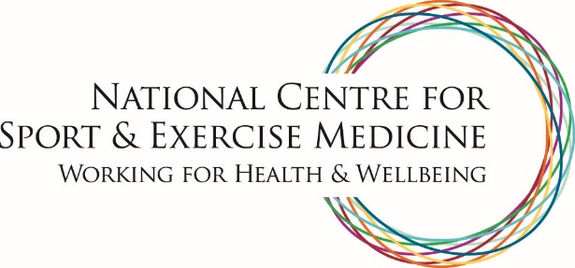

Sheffield
NCSEM Sheffield is focused on the design, implementation and evaluation of whole-system approaches to increasing physical activity across the population.
At the heart of the project is Move More, an evidence-based, city-wide public health programme, which aims to re-engineer physical activity back into daily life through meaningful changes to the physical and social environment of a city, including communities, schools, workplaces and transport infrastructure.
The work of NCSEM Sheffield also includes the development of physical activity pathways within the NHS. An innovative hub and spoke capital model co-locates patients, researchers, clinicians, sport and exercise medicine specialists and public health professionals, and adopts user-centred healthcare design principles to co-produce new models of care with patients and stakeholders.
NCSEM Sheffield is a partnership between Sheffield Teaching Hospitals NHS Foundation Trust, Sheffield Hallam University, The University of Sheffield, Sheffield Children’s NHS Foundation Trust, Sheffield Health and Social Care NHS Foundation Trust, Sheffield City Council, Sheffield Clinical Commissioning Group, Voluntary Action Sheffield, Sheffield Chamber of Commerce, Sheffield International Venues and the English Institute of Sport.
W: www.movemoresheffield.com
T: @movemoresheff

